Experiment 5

# Aim:

a) Write a Perl program to display various Server Information like Server Name, Server Software, Server protocol, CGI Revision etc.

b) Write a Perl program to accept UNIX command froma HTML form and to display the output of the command executed.

# HTML:



Code 1: 5a.html

# PERL:



Code 2: 5a.pl

# Output:

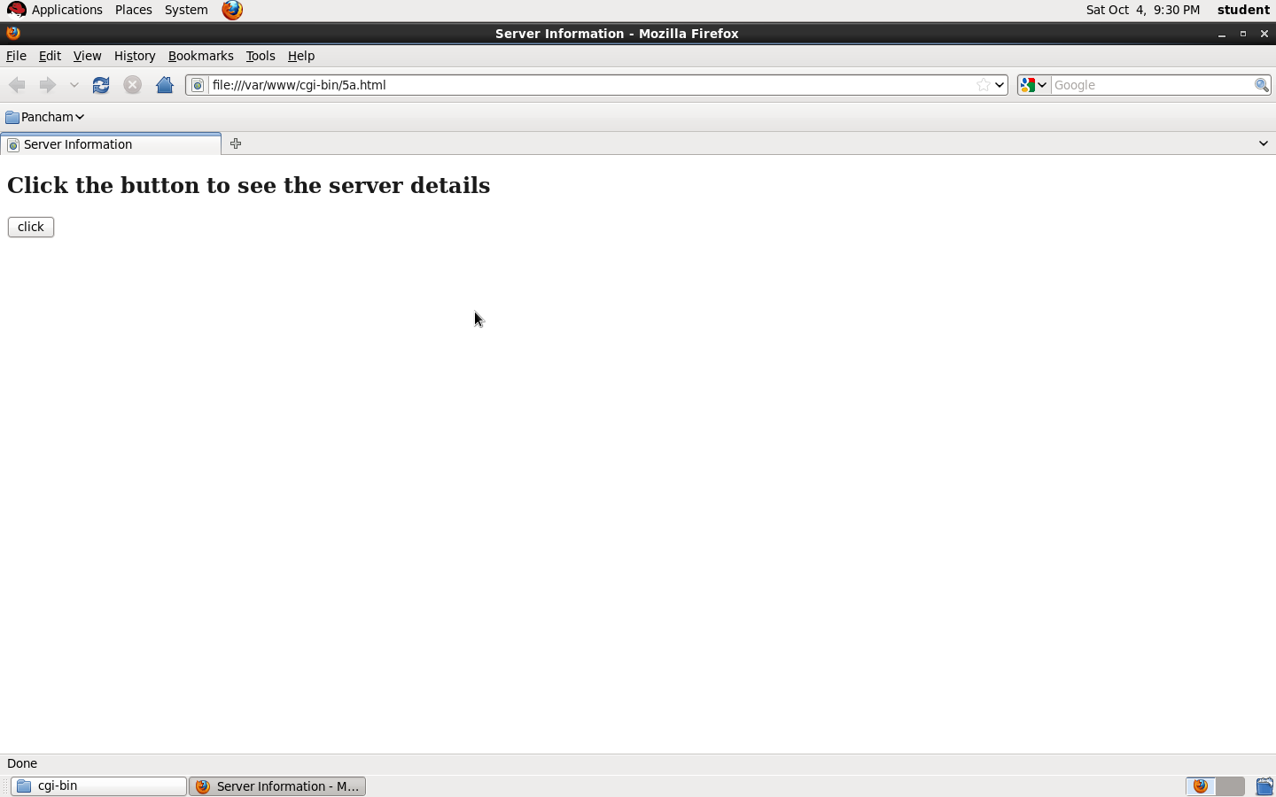

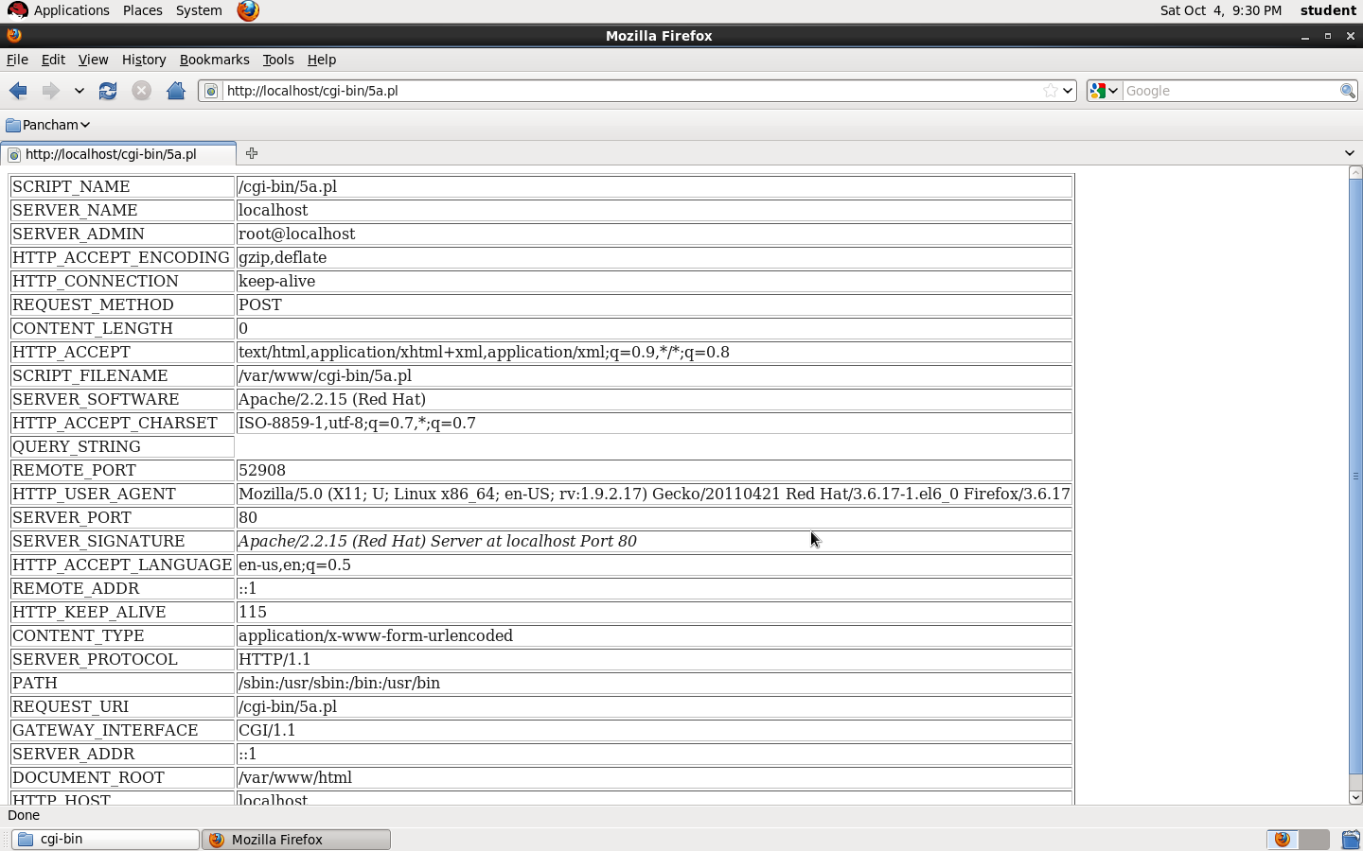

# HTML:



Code 3: 5b.html

# PERL:



Code 4: 5b.perl

# Output:

